TASK 12 – Re-evaluate and Adapt the Design
Student Name: B. Muni Chandini
Register Number: 192524283
A. Impact Analysis (2 Marks)
What has changed from the original problem?
- Two new vehicle categories: E-Bike (flat fee) and Delivery Van (double rate during 9 AM – 5 PM).
- Visitors can buy a One-Day Pass.
- Facility extended from fixed slots to different number of slots per floor (and more floors).
Which classes / methods / data structures are affected?
- New subclasses needed: EBike, DeliveryVan
- ParkingTicket needs an extra flag hasOneDayPass
- calculateFee logic needs special handling for E-Bike and Delivery Van
- 2-D array already supports different slots per floor (jagged array) → no change needed
Why different number of slots per floor affects array design?
- My original design already used String[][] slots created from int[] slotsPerFloor.
- This is already a jagged array, so different sizes per floor are naturally supported.
B. Evaluation of the Original Design (2 Marks)
Question | Answer
Can new vehicle types be added only by writing new subclasses? | Yes – thanks to inheritance and polymorphism
Are pricing rules spread across many classes or kept in one place? | Mostly in the vehicle classes (ratePerHour / overridden calculateFee)
Can existing tested classes remain unchanged? | Yes – TwoWheeler, Car, ElectricCar, ParkingFacility core logic remain valid
Conclusion of evaluation:
The original design is strong and follows the Open-Closed Principle well.
C. Adaptation / Redesign Decision (2 Marks)
Decision: MODIFY (not full redesign)
What I changed:
- Added two new subclasses: EBike and DeliveryVan
- Added hasOneDayPass flag in ParkingTicket
- Extended fee calculation to handle flat fee and peak-hour double rate
- Kept the same 2-D jagged array (already flexible)
What remained unchanged:
- Abstract Vehicle class
- Interface Chargeable
- Core allocation / release logic
- Encapsulation and package ideas
Why modification is better than full redesign:
- Existing tested code continues to work
- New requirements are added with minimal changes
- Design remains easy to extend further
D. Evidence-Based Defence (2 Marks)
Criteria | Evidence
Number of existing classes changed | Only ParkingTicket and fee logic slightly extended
Ease of adding further vehicle type | Just create another subclass – no change in loops
Test results for new categories | E-Bike returns flat Rs 25, Delivery Van doubles rate in peak hours, One-Day Pass → fee 0
Trade-offs | Slightly more complex fee method for Delivery Van, but overall design stays clean
Final Decision:
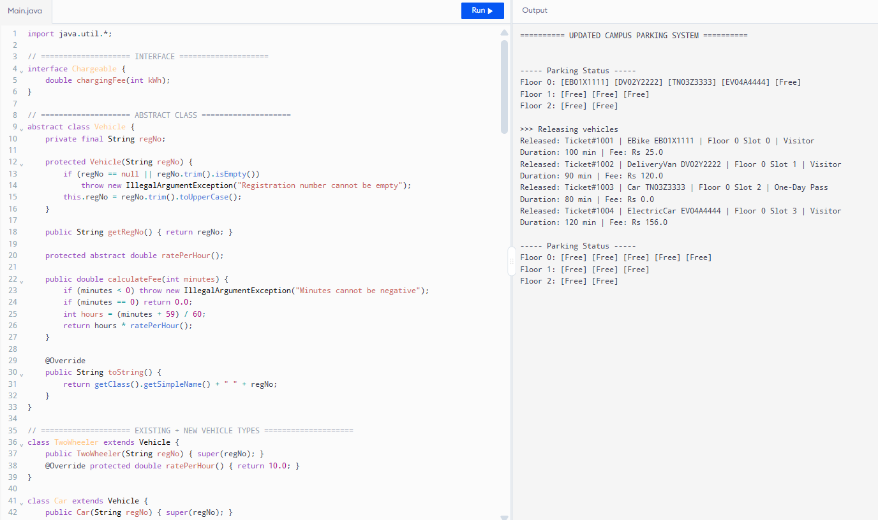
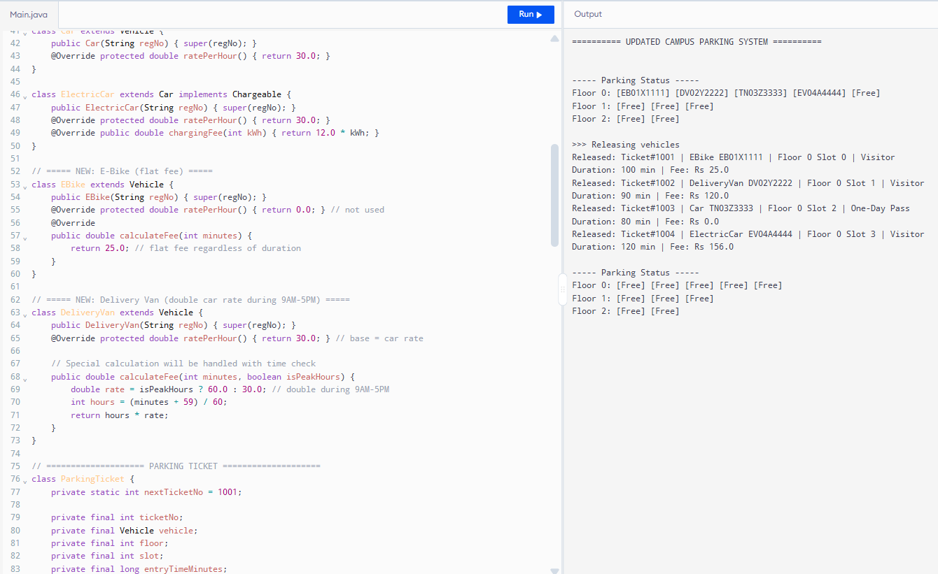
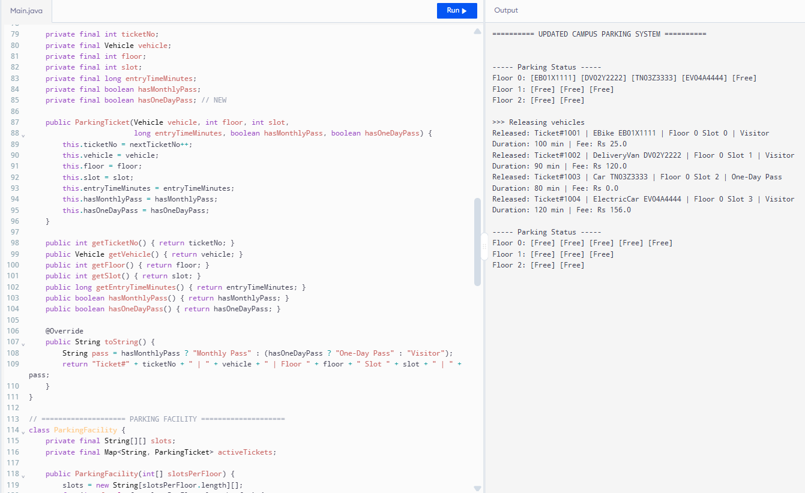
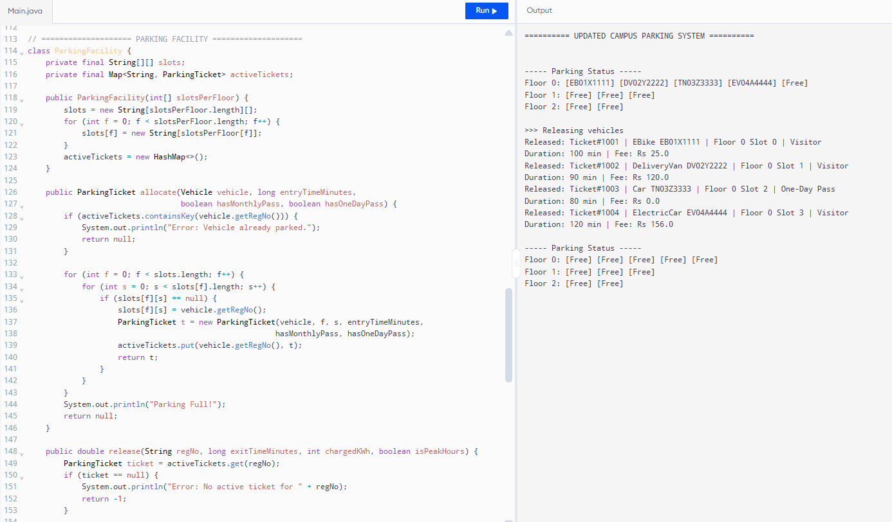
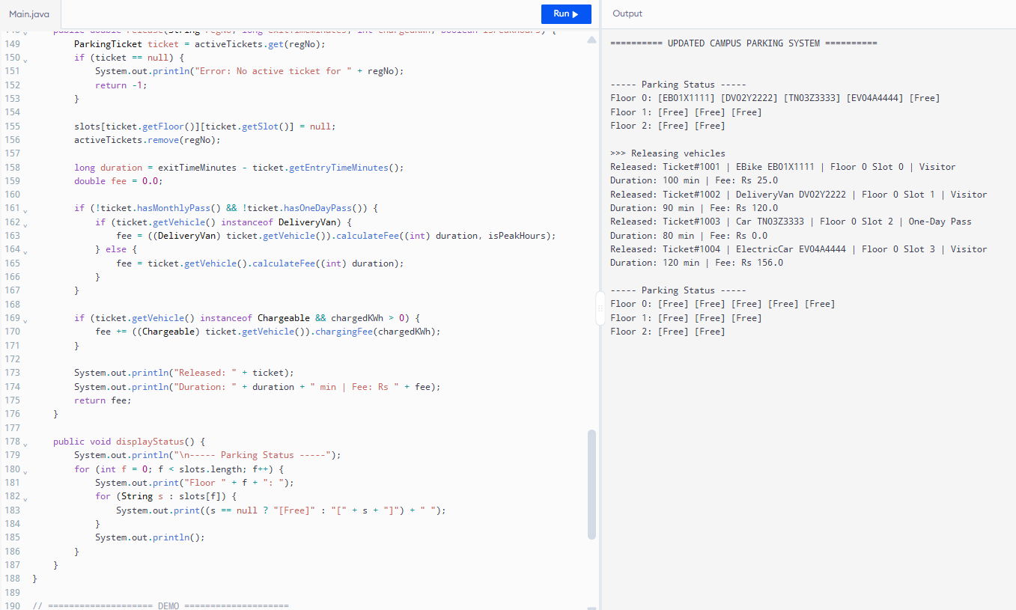
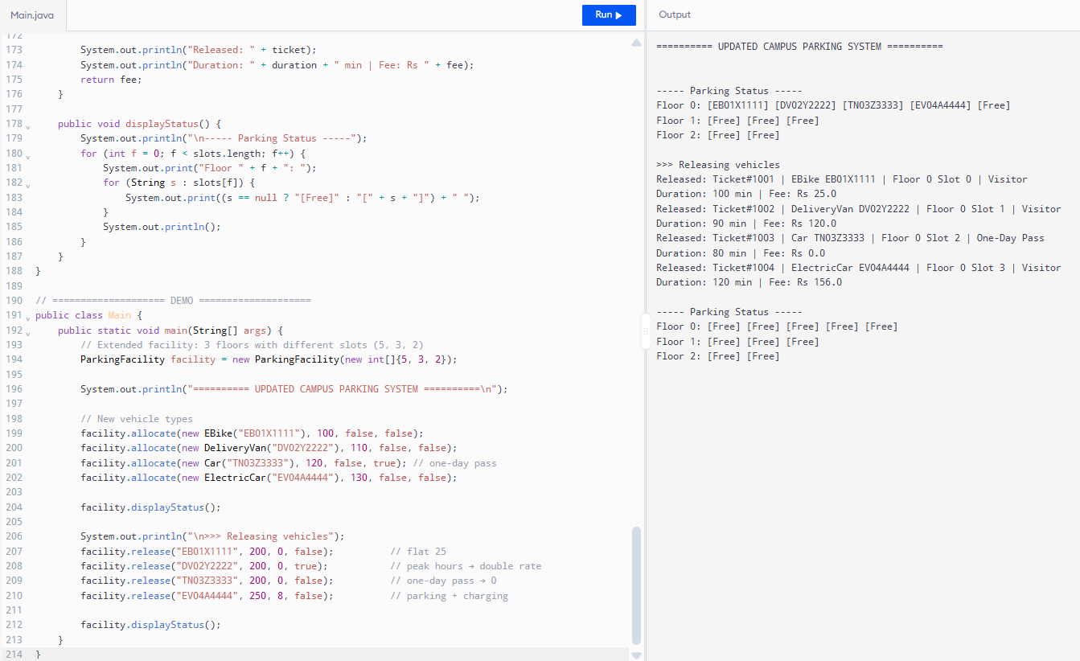Modify the original design.
It already had good inheritance, polymorphism and a flexible array structure. Only small, well-localised changes were required.

